Journal Writing Prompts - 2


Daily Journal
Write a letter to a friend outlining what
you like about them.
wordsonalimb.com 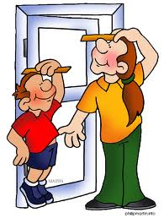

Daily Journal
Kids should be allowed to eat junk food
all the time because…
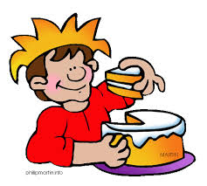 wordsonalimb.com

Daily Journal

If I was stranded on a deserted island
and I could only bring three things, I’d
bring…

 wordsonalimb.com

Daily Journal

If I could make up a new rule for our
class, it would be…
wordsonalimb.com 

Daily Journal

Write about a strange dream you had.

wordsonalimb.com 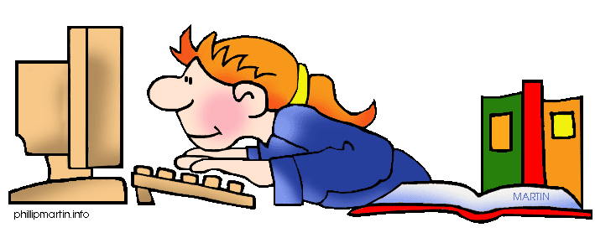

Daily Journal

Homework should be banned because…
 wordsonalimb.com

Daily Journal

Mondays should be part of the weekend
because…
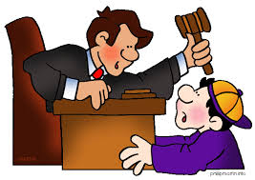 wordsonalimb.com

Daily Journal

Should we have school on Saturdays?

wordsonalimb.com

Daily Journal

Should kids get allowance?
 wordsonalimb.com

Daily Journal

Parents should go to school because…

wordsonalimb.com 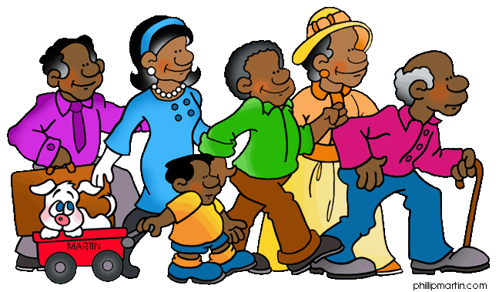

Daily Journal

Write about a country you’d like to visit.
wordsonalimb.com 

Daily Journal

Write about your favourite TV show.
wordsonalimb.com
Daily Journal

The best place I’ve ever visited is…
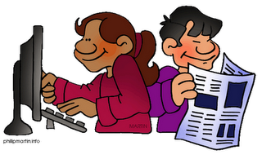 wordsonalimb.com

Daily Journal

My favourite singer is…
 wordsonalimb.com

Daily Journal

If I could be anyone for a day, I’d
choose to be…
wordsonalimb.com

Daily Journal

If you could see the future what would
you want to know?

wordsonalimb.com

Daily Journal

Where would you go if you could travel
back in time?
wordsonalimb.com

Daily Journal

I wish I had a…

wordsonalimb.com

Daily Journal

The best thing about the media…

wordsonalimb.com

Daily Journal

The worst food I ever ate…

wordsonalimb.com

Daily Journal

A dream I have is…
wordsonalimb.com

Daily Journal
What are you fears?

wordsonalimb.com

Daily Journal

Write about your first trip to the farm.
wordsonalimb.com

Daily Journal
Write about your first visit to the
dentist.
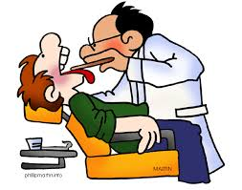 wordsonalimb.com

Daily Journal

Having a good job is important because…

wordsonalimb.com

Daily Journal

What is happiness?

wordsonalimb.com

Daily Journal

Someone I am afraid of…
wordsonalimb.com

Daily Journal

What cheers you up when you’re upset?
wordsonalimb.com
Daily Journal

My favourite holiday…
wordsonalimb.com

Daily Journal

How can we make the world a better
place?
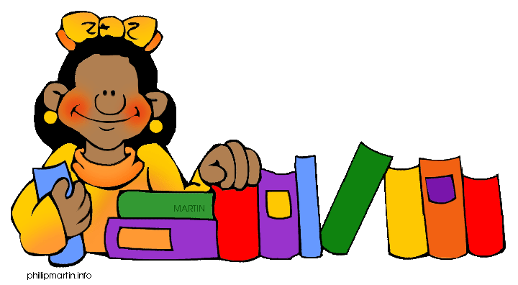 wordsonalimb.com

Daily Journal

The worst month of the year…
wordsonalimb.com

Daily Journal

The worst day of the week…

wordsonalimb.com

Daily Journal

Computers are great because…

wordsonalimb.com

Daily Journal
Things I am thankful for…
wordsonalimb.com 

Daily Journal

The best joke I ever heard…
wordsonalimb.com

Daily Journal

The best age is…

wordsonalimb.com

Daily Journal

The best thing about babies…
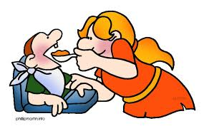 wordsonalimb.com

Daily Journal

My favourite book…
wordsonalimb.com

Daily Journal

Write about something you heard on the
news.
wordsonalimb.com

Daily Journal

I appreciate it when…

wordsonalimb.com

Daily Journal

My favourite costume…
wordsonalimb.com 

Daily Journal

The best story I ever heard…
 wordsonalimb.com

Daily Journal
Write about chores you have around the
house.
wordsonalimb.com 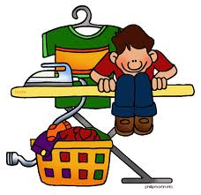

Daily Journal

Write about a recent trip to the doctor.
 wordsonalimb.com

Daily Journal

The best food ever…
wordsonalimb.com

Daily Journal
Someone I look up to…
wordsonalimb.com 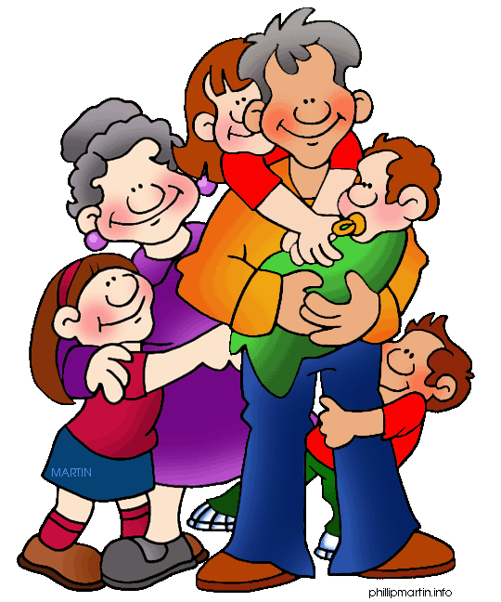

Daily Journal

Teachers shouldn’t be allowed to…
 wordsonalimb.com

Daily Journal

Parents shouldn’t be allowed to…
wordsonalimb.com

Daily Journal

The best thing about the beach…
wordsonalimb.com

Daily Journal

Write about things that make you
nervous.
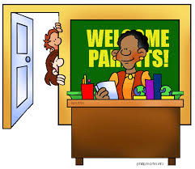 wordsonalimb.com

Daily Journal
The hardest job in the world is…
wordsonalimb.com 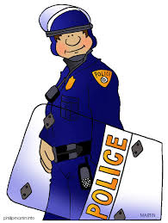

Daily Journal

Why should we recycle?
 wordsonalimb.com

Daily Journal

Someone famous I wish I could meet…
wordsonalimb.com

Daily Journal

Should kids be allowed to go to bed
whenever they want?
wordsonalimb.com

Daily Journal

Write about your first time on a plane.
wordsonalimb.com

Daily Journal

Write about your first trip to another
country.
 wordsonalimb.com

Daily Journal
If a genie could grant you three wishes,
what would you ask for?
wordsonalimb.com

Daily Journal

Write a letter to your mom or dad,
convincing them to let you stay up later.

wordsonalimb.com

