Please Stay Awhile

By Lora Rozler


Take a peek -
A warm greeting smile.
Come in, explore -

Please stay awhile.

Books to read,

And songs to sing,
Games and fun
In everything.


Friends to grow with,
Share and play,
Work and learn
Each bright new day.

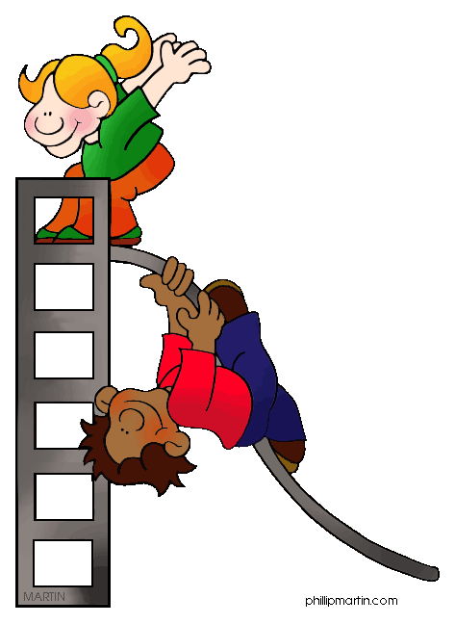
Take a peek -
A warm greeting smile.

Come in, explore -
Please stay awhile.

wordsonalimb.com

